**Exercise 11 Aquamaniac Homepage Layout in Traditional Style**

In this activity you are going to set up the major areas of the Aquamaniacs home page based on the HTML skills you already know.  The Aquamaniacs home page will have a header, footer, navigation bar, and main content area.

**Part I Main Page Layout**

1. On Window’s explorer, create Aquamaniacs folder under your web programming folder, net to the Raptor folder you created before.
2. In KomodoEdit, create a new project Aquamaniacs, save it to the Aquamaniacs folder you just made.
3. Create index.html file in the project and save it to the above. Hope you already remember how to do it.
4. On the file, create a head, and a body section. Remember how to do that?

You will need to add several **<div>** elements to the **<body>** section of your "index.html" file. Go ahead and run Komodo Edit and open this file in the Edit pane. The final design for the body of your web page should look something like the image to the right.

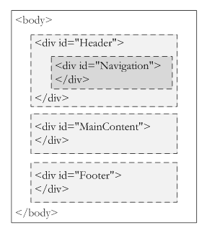Inside the <**body**> element, complete the following steps:

1. Add the <**div**> with the "Header" **id**
2. Inside the "Header" <**div**>, add another <**div**> with an **id** of "Navigation"
3. Below the "Header" <**div**>, add a second <**div**> with an **id** of "MainContent"
4. Below the "MainContent" <**div**>, add a third <**div**> with an **id** of "Footer"

Next, fill out the "MainContent" <**div**> with the mark-up shown below. You can simplify the content if it is too much typing for you. But keep all the html tags.

<h1>Welcome to Aquamaniacs</h1>  
<p>Our oceans hold many <em>wild</em> and <em>wonderful</em> sea creatures. Here, you can learn about large animals like whales, dolphins, and sharks. See oddities like the sea urchin, longhorn cowfish, emperor penguin, lobster, lionfish, cuttlefish, and seahorse. <strong>Don't forget</strong> to visit the octopus and otter!</p>  
<p>Follow our navigation links to learn about <i>"Big Critters"</i>. Check out the crazy things hidden under the <i>"Oddballs"</i> category. Enter our "Multimedia" lab for photos, sounds, and videos. <b>Don't forget</b> to see our <i>"Animation"</i> area for some funny effects!</p>

Don't forget to use good **indentation** or **spacing** to make your page human-readable! Child elements should be indented several spaces inside parent elements.

When you have finished adding your <**div**> sections and typing into the "MainContent" area, save your file.  Then use the "Browser Preview" feature in Komodo Edit to view the new web page. Your results should look something like the screen below:

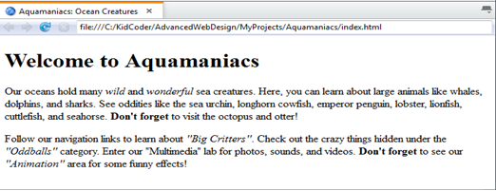

**Part II** **Initial Styling**

Let’s use Komodo Edit to create new external CSS for us so we can start building some site styles.

1. In the left-hand Komodo Edit project panel, right-click in the empty area underneath "index.html" as shown in the image to the right. In the menu that appears, select "New Folder...".
2. Type in the folder name "SiteStyle" and hit OK.

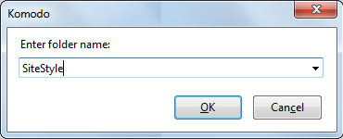

Now you have a new "SiteStyle" sub-folder, and you didn’t have to use Windows Explorer or Mac OS Finder!

1. Right-click on the "SiteStyle" sub-folder and select "New File From Template…".
2. Select "Web" in the left panel and "CSS" in the right-hand side.  Type in "global.css" for the filename and click "Open".

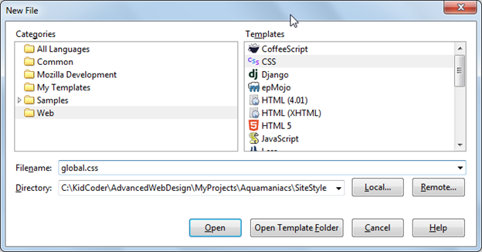

1. Add the following styles to "global.css" for <**em**>, <**i**>, <**strong**>, and <**b**>. Don't forget you can cut and paste directly from the text box below if you don't want to type everything out by hand.

em {  
   font-size: 20px;  
   font-style: normal;  
   color: red;  
}  
i {  
   font-size: 20px;  
   color: purple;  
}  
strong {  
   font-size: 25px;  
   font-weight: normal;  
   color: blue;  
}  
b {  
   font-size: 30px;  
   color: green;  
}

1. Click on the "index.html" tab to return to your main page. Add a link to your new stylesheet inside your <**head**> element:

   <link rel="stylesheet" href="SiteStyle/global.css">

</head>

1. Save your results and load the page in your web browser or Komodo Edit preview panel. Each of the <**em**>, <**strong**>, <**i**>, and <**b**> elements should now look different.

